Appendix 1 Survey of participants
An electronic survey was sent out to attendees at Community Bushfire Connection events and lodged on both the webpage and facebook page to encourage feedback on the program. The results are summarised below

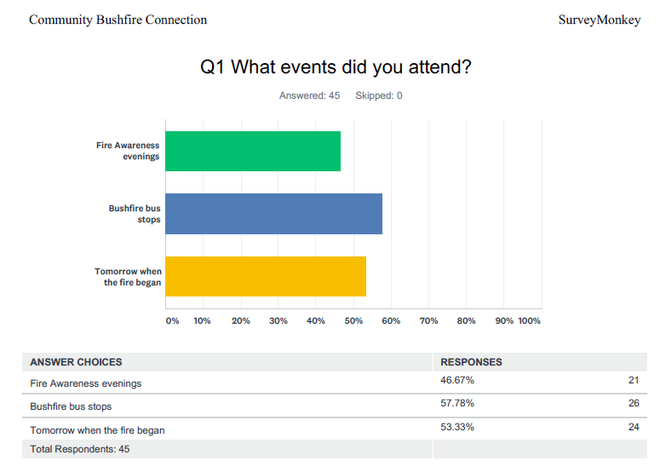

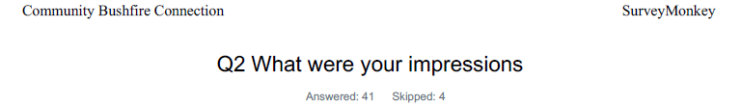
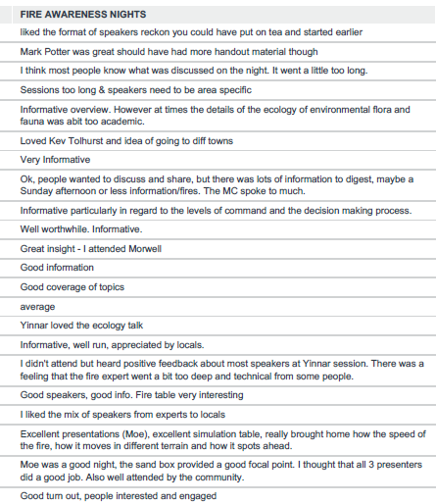

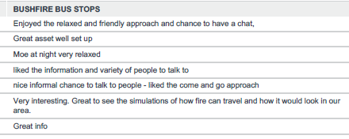
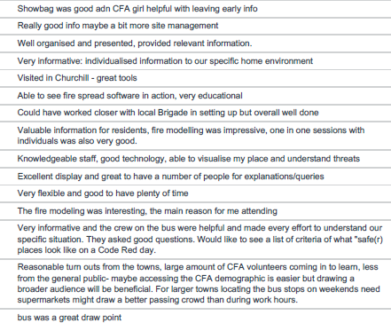
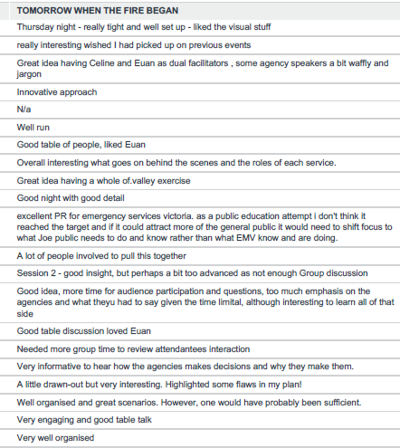
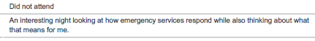

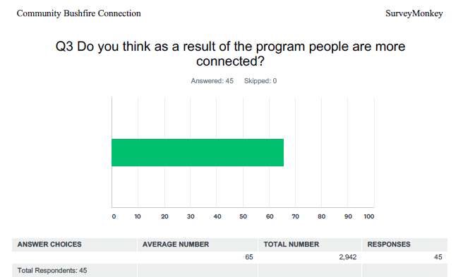

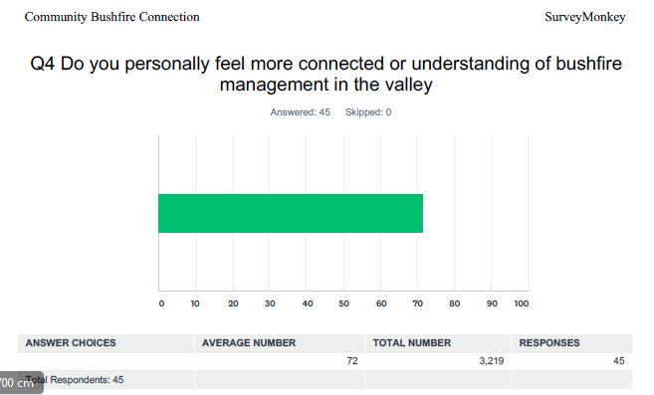

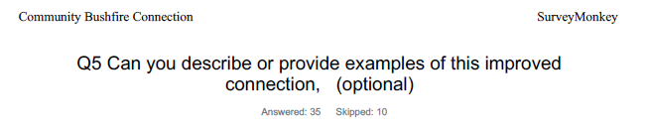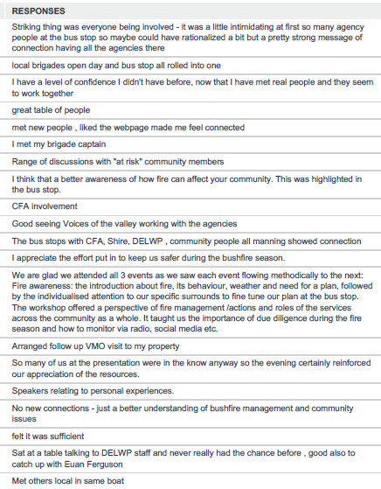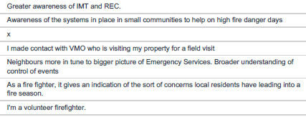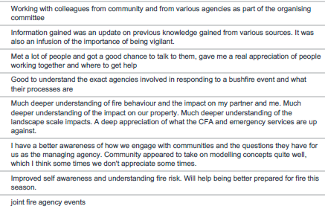

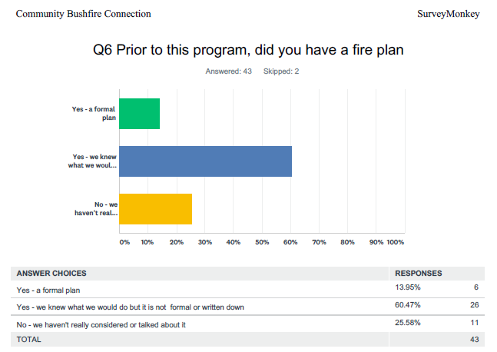
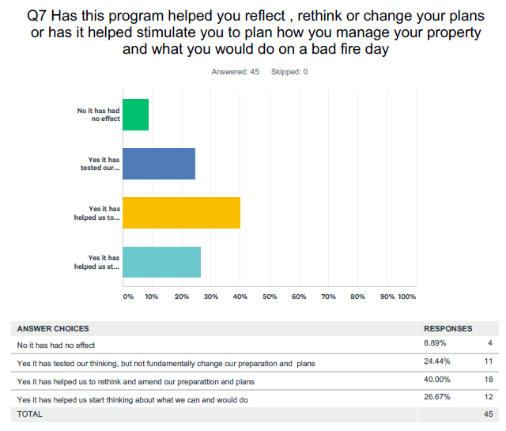

Q8 Community Bushfire Connection
Do you have a better understanding of bushfire hazard and risk associated with living where you do
Responses
yes
yes around our house and nearby area
Moe South resident - I knew it was risky but to have it explained eg where fire could come from was really good
loved phoenix and the videos really brought to life
yes the overall picture
yes
I think we have always been aware of how fire could impact our lives and the risk we have according to where we live. It is good though to revisit and to be reminded of the changing climate and the changing behaviour of fire.
yes
yes
yes HILI was great to see where risk was and what could do about it
I have generally had a good understanding.
Yes we certainly do. Although we were aware when moving to the bush that we would live in a bushfire prone area we accepted the risk. We also knew we needed a better understanding of fire, its management to be proactive and prepared. That is why to us the events were so valuable. We are from North Queensland and experienced Yasi, Larry and Steve so we are well aware not to be complacent.
Yes ESP the repeated history in the area the website is great hope can keep it going
Yes I do
Nothing specifically about where we live - small town suburb/urban fringe.
Yes
I have slightly better understanding of bushfire hazard
Yes. I now know that living in the center of town is no guarantee of safety from fire.p
I believe so
Yes especially the complexity of it, and the thinking behind warnings
No difference - in a fire brigade as Captain
Yes
Yes, more knowledgeable
x
yes I think I do thanks to this program
I was well aware of risk in area.
I don't think I have learn any more than what I already knew. Courtesy of being involved in some form of fire management over 4 decades.
No
Yes I have a good understanding as we live in the bush.
Yes
Yes
Yes it was great so many people took the time to talk to me
Yes slightly. The model indicated illustrated more threats to our property from a further distant than I thought
Yes
Yes, much better. It has helped shape our plans.
NA- part of department
Yes
yes
yes
NA

Q9 Community Bushfire Connection
What would you have liked to have learned more about ?
Responses
I would have liked perhaps a better understanding of shire works perhaps could have had a more active role in the bus stop with maps of roadside veg works etc
joining the CFA
fire behavior and maybe about local contacts - property owners who have plans etc
evacuations, Police role
phoenix
house protection
Landscaping in bush fire prone areas.
Managing your pets and recovery
planting around my home, got the book but more time to discuss
Preparing the house and surrounds to minimise fire risk and damage. However on exploring the Community Bushfire Connection we found the powerpoints from other towns where this was discussed.
Evacuation and care of the vulnerable and hints for pets
See question 8.
More about our own C.F.A. volunteers.
Nothing more
Support for elderly people living alone and those who do not have a computer of mobile phone.
Feel that the night covered the essentials
Traffic management
Specific to an area - more bushfire bus time.
The relationship between all emergency agencies and greater knowledge of how they all work together.
x
phoenix
Overall very informative and targeted at people rather agencies
nil.
Any additional information is available to me online or through the brigade membership if needed.
Not applicable
More time to discuss others’ plans and pick up on ideas from talking to others might have been nice.
Current planning provisions for towns in relation to plantations and existing forests.
House retro fitting, Mark Potter was very engaging but liked to hear more
It would be nice to run the model under more scenarios for my location.
warning messages and processes
I regret not being able to get to the "Tomorrow when the fire began." I find understanding how the big picture is managed very helpful in making my personal plans. I would like to know if there is a resource on the internet of videos of fire behaviour and how it is managed - maybe with an expert CFA commentary.
NA- part of department
Plans for controlled burning near my house
0

Q10 Community Bushfire Connection
Do you have any feedback for the Community Bushfire Connection working group
Responses
I love the bus stop concept perhaps a bit better connection with the local community and liaison re timing and location
Really helpful and polite staff , could of had a few more prominent locals or community people to talk to
Really friendly and helpful vibe - liked that went past the usual rhetoric and explained things
it takes a while to get these things off the ground I reckon next year you will have heaps of interest
so much work, loved the way worked together
great job
More consultation with the local brigades who could assist with advertising and promoting the event in their local community.
Ambitious program and hard to sustain but keep it up
Bus stops were great maybe an extended version next year
Unfortunately we never made it to the feedback sessions in Traralgon. A number of our questions were written and displayed on the screen at the "Tomorrow when the fire began" however we have not heard back with its answers even though we gave our email address. Would these answers be entered in the Community Bushfire Connection?
Extend network beyond CFA and voices of the valley
See above comments
Hit the streets & connect with the community.
Great work - on reflection the methods of using different ways to connect with the community, informing and encouraging further planning further is very worthwhile
Pleased to have a better understanding of processes involved.
More information regarding evacuation centers and personal roles, assistance provided etc.
Better advertising. Brochure for this year was very "wishy-washy" could understand that people would not take any notice of it.
Maybe a bit better and earlier engagement with the brigades
More individual time - better located bus in Churchill without the late change. Better in shopping centre precinct.
Good work on the initial trial of this activity. Good having expert presenters such as Dr Kevin Tolhurst, learned quite a bit even though I'm a CFA volunteer.
Great learning outcomes available to all. Keep it up
no
Please go again next year and consider more tailored small town scenarios
Great presentation and variety of reaching the Public well done. Coming to the people.
Great initiative for small communities in particular.
Gives CFA members an opportunity to touch base with and further develop that connection which is important,.
From a local Brigade point of view:
These sessions were valuable for members of our community BUT
There should have been far better communication to local brigades in a more timely manner about what was expected of them.
It would have been great to connect these in with Brigade open days.
Locals had no input into best times of visits and locations for the bus in their communities
As Brigade captain I had to chase the project members for information
Also, and this is hugely important, if you are bringing people with from outside the area (ie Melbourne) please brief them on Fire history in the communities they are visiting. One of my members, who lost everything he owned in the Delburn fires in 09, had a presenter say to him "apparently you guys had a bit of a fire here a week after Black Saturday". He's a pretty together bloke but he was quite upset by firstly, the offhand and patronising statement and secondly, the inaccurate knowledge. If you are visiting a community which has been impacted by a significant fire, please be mindful and respectful of that. Nine years on our people still have scars.
This was a very valuable exercise and needs to be pushed out to more people.
It was a pretty big program! As a member of the working group I think we did pretty well. We learnt some lessons too - pick up the pace in the scenarios and allow more time for discussion/reflection.
Pre-time components of presentation sessions. There is research regarding optimal intake and concentration spans. Evening sessions have to consider that people are attending after a busy work-day.
Great job and yes you should keep going
None, I think it was well run and the dynamic road side signs on main roads where a good, timely reminder about the bus dates/times.
For a scenario exercise, it lacked the sense of urgency that would test people's responses. Hard to know how to do this, but the evening was very relaxed and drawn out. I think that you could have achieved the same result in 2 hours.
It was obviously extremely well planned and supported by agencies.
The test warning messages were far too long.
Yes, more next year for more people! Great program. The more communities learn about what you do, the more we can work to prevent fires in the first place and the more we can support the CFA.
No
there needed to be a lot more local consultation, the events could have been facilitated alongside other community events to seek more public interest. Brigades were not consulted enough and or involved after the planning had already been done, brigades are the community so their voices should have played a larger role.
Session went too late. Either start earlier, shorten it or put it on a weekend??
Seemed like a useful and well presented series of events

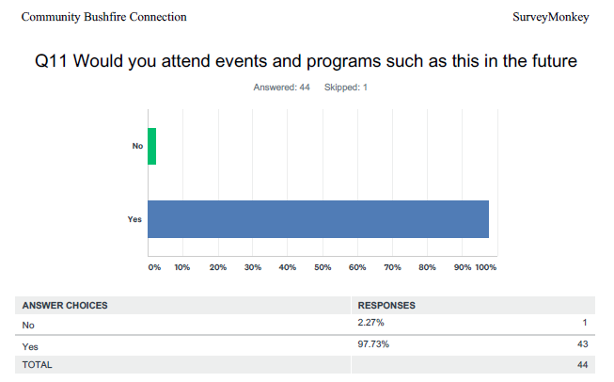
Any comments - particular events you prefer
I really like the flexibility of the bus stop approach and chance to arrange a more formal CFA visit later
don't normally attend CFA things as they are a bit preachy but this was good honest conversation not just propaganda
Tomorrow when the fire began - have a few ideas how you could expand / build on this
definitely really want to go to the bus stop
think be good to advertise way out and get people to register , maybe with a reward for participation
would have liked to have gone to other things but Nov is a busy month
A refresher event and to learn about updated knowledge pertaining to fire behaviour, management and preparation.
Spread it out a bit and try not to clash with CFA pre season events
Tomorrow when the fire begins style format
Speakers within the local community I would call it
back to grass roots.
Yes, any chance to facilitate and build on experience and learn (even if it is in another region) is worthwhile for my learning and development
I missed the bus stops but would be keen to do that next time
loved the fact talking about fire ecology
Possibly - would depend on other commitments and so on.
We'd return to the events attended - they were well-resourced and planned. Thank you (the only issue was length of presentation)
liked the bus stops
All were good. Sorry I missed the TWTFB
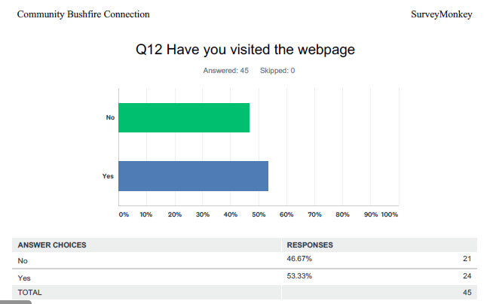
Any suggestions or comments
saw it in the bus, good it has all the plan templates
for info on events and to register for scenario
easy to get around liked the personal touch with pictures and profiles of organisers , makes it more human
graet info loved the map
love it be good if it had info on the bushfire royal commissions findings and also the Hazelwood one
Loved how the powerpoints from other Fire Awareness sessions in other towns was available for viewing.
I love it need to grow the stories part of it
Will check it out.
Its very user friendly - it might be nice to have an "after bushfire season event" to celebrate all the work done, community participation in these events and if all goes well and there is no fire, combine this with a general community happiness event that the fire season is over
Intend to.
Good beginning. Will need to evolve and be kept up to date as time passes.
There's a lot of information on it.
not yet, but I plan to.
so much info I hope can keep it going
Not yet

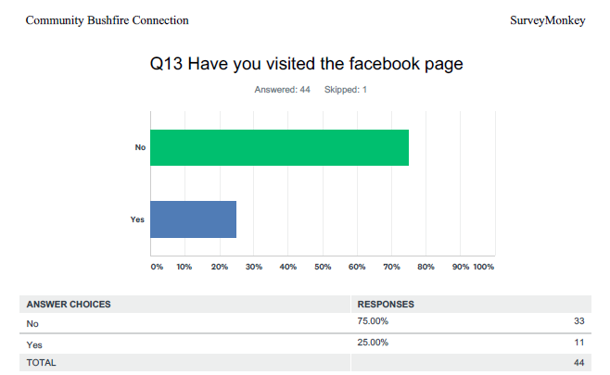
Any suggestions or comments
got a message passed on which led me to attend
fun stuff promoting events
Not on facebook
good reminder of events
no - but I will
Will do
helped prompt when things were on not sure if it will work long term
Not yet

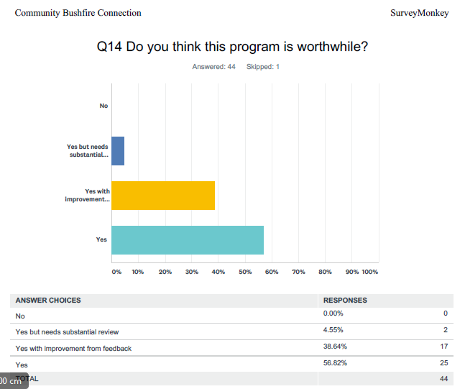
Suggestions / comments
great having so many options and like that bus returns to a town so could tell others
Just seemed to be so well organised
maybe move scenario around the valley
just wished I had gone to more of it, timing needs review Nov is a bit of a problem
I guess there will be lots of ideas so plenty of ways to make bigger and better next year
can always improve , guess you just have to keep at it too
Involving young people - an education link
This program is vital for new residents and a refresher for current residents
Sure organisers will learn and improve anyway hope they don't burn out with one event
Let us connect to our own local C.F.A.
Yes
from what I saw of the audience and some posted questions it felt like you were preahing to the converted
See above.
A great program, well run and very informative.
Can always improve but fantastic initiative well done to all
Always room for improvement, but it is already very good. How about a stand at some of the farmers markets, if you are not already doing that.

Q15 Community Bushfire Connection
Any last thoughts
Responses
need to keep the website current and relevant ( big test) and add maybe presentations and research stuff
see you next year, can you add more towns in ?
it is quality of interaction , not numbers that matter - that is what I liked about the community evening and the bus stop
Thank you for offering the opportunity to see the bushfire bus. I would have liked to attend 'tomorrow when the fire began' but it did not fit into my schedule at the time. Perhaps holding the event in October to get people thinking about their fire preparedness earlier might not be a bad idea.
I learnt stuff and met good people can't ask for much more really
I know it is hard to maintain interest but even getting a few people more prepared makes it worth it
The kids loved the bus & the free ice creams - Thanks!
We are looking forward to a visit from CFA to assess our home and bush for a fire risk assessment and fine tune our Fire Plan..
We commented that there must have been a huge effort and energy in organising these events. Thank you.
Look to establish other branches or programs across Gippsland
Just well done by the Committee and everyone.
I am CFA member with time to attend so I hear the message but you need to reach the un-connected - just how I don't know sorry.
Try connecting with local community groups this will then become the best marketing tool.
Well done - lots of thought/hard work went into this and it shows
Thank you for provided some understanding of the preparedness of our services should there be a fire.
Well done everyone involved
Well done. How do you get the majority of the uninterested involved when their place is at threat ?
I got a lot out of it, if it runs next year will recommend to others
Direct community connection is better than mail-outs, electronic information.
Good to see key agency members present to the community. This must instil confidence in the community the need for good planning pre fire season.
For a pilot project, the concept is great BUT you need to be working much more effectively WITH the smaller communities that you visit. Most of our little towns have very strong community based groups and networks that you could be tapping into but you need to get those groups and local brigades involved far, far earlier and communicate with them much, much better.
??
This is great for renewing awareness and for raising levels of preparation and vigilance.
Maybe see it expand out across Gippsland
A very good program - more input from community at these events would be beneficial for both agencies and community.
The real time feedback/twitter-esk feed was very good.
Great job!
Nice innovative way to help build a public image and stimulate bushfire thought. I think it was run very professionally and coordinated well. Timing and location o the bus stops I think could be improved possibly to have a greater turn out, but in saying that- what was done was still very successful. Hopefully the event will promote a broader audience to attend next time.
No. Well done.
The experts and people with experience on the panel was really important. Their knowledge and experience really came through and gave confidence that what we were hearing was accurate to what a real event would be like.

