Appendix 3 Budget detail

Review expenditure and approve upcoming expenses

Initial budget from agreement

Agreement required DELWP to ..
Provide a budget, identifying the different items (eg labour, consultancy fees, materials, equipment etc). Budgeted costs must be GST exclusive. The budget is to include the estimated cash value of any in-kind contribution. For this project inkind labour was the major contribution of DELWP and working group members

Estimated budget in initial application
Element | $
Consultancy Fees | $15000
Professional Services | $50,000
Project Management | $45,000
Administrative Costs (eg postage, stationery, printing, telephone) | $10,000
Equipment | $20,000
Construction | $
Travel and accomodation | $10,000
Other | $20,000
Total (GST exclusive) (must equal Q 12 total) | $170,000
The following table indicates the agreed contribution from the NBMP and program partners.As per the agreement the contributors’ total contributions, must equal or exceed the NBMP amount. Include the estimated cash value of any in-kind contribution.
Contributor | $
NBMP (Commonwealth) | 85,000
Applicant contribution:
- Cash
- In Kind | 30,000
Other partners (Q 13):
- Cash
- In Kind | 55,000
Total: (must equal Q 11 total) | 170,000

Summary of in kind contribution of working group partners

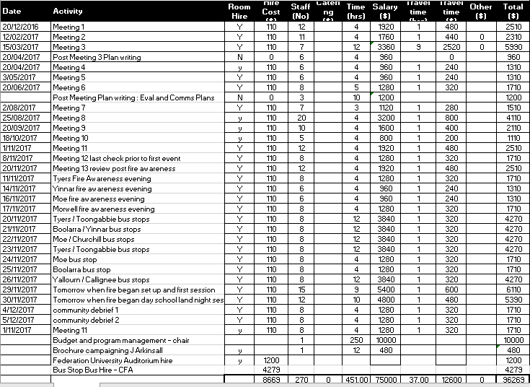

Total in kind contribution : $96,269

Summary of costs incurred and processed to the NBMP funding of $85,000

Vendor/Customer Description | Batch/Invoice Description | Posted date | Amount
IMAGE DIRECT WORLD ENTREPRENEURS | Web page development | 1-Jul-17 | 5,700.00
IMAGE DIRECT WORLD ENTREPRENEURS | Web training - 1 day J Pakan | 1-Jul-17 | 80
IMAGE DIRECT WORLD ENTREPRENEURS | Business cards | 13-Nov-17 | 78.37
IMAGE DIRECT WORLD ENTREPRENEURS | Promotional posters | 13-Nov-17 | 152.92
IMAGE DIRECT WORLD ENTREPRENEURS | Additional poster run | 13-Nov-17 | 232.33
IMAGE DIRECT WORLD ENTREPRENEURS | Poster run 3 | 13-Nov-17 | 387.51
IMAGE DIRECT WORLD ENTREPRENEURS | Poster run 4 | 13-Nov-17 | 507.05
CHRIS HUMPHREY OFFICE NATIONAL | Stationary for CBc | 12-Dec-17 | 75.45
BRIDGES ON ARGYLE | CFA attendee to CBC | 16-Nov-17 | 160
TYERS PRIMARY SCHOOL | Room hire CBC | 21-Nov-17 | 373.82
NATURAL SYSTEMS ANALYTICS | Provision of phoenix products | 21-Sep-17 | 7,800.00
PRORENT PTY LTD | Messaging board for CBC | 1-Dec-17 | 560
NATURAL SYSTEMS ANALYTICS | Phoenix analysis LV | 6-Dec-17 | 11,700.00
TOLHURST BUSHFIRE SERVICES | Kev Tolhurst charge for CBC | 7-Dec-17 | 312
DAN CLANCEY | Video production | 7-Dec-17 | 4,700.00
EUAN FERGUSON PTY LTD | Facilitation of CBC event | 12-Dec-17 | 1,844.32
FEDERATION UNIVERSITY AUSTRALIA | AV support for CBC event | 12-Dec-17 | 909.1
BRIDGES ON ARGYLE | Accom for CBC workers | 24-Nov-17 | 447.27
BRIDGES ON ARGYLE | Accom for CBC workers | 24-Nov-17 | 480.91
BRIDGES ON ARGYLE | Accom CBC | 27-Nov-17 | 163.64
COMFORT INN TRARALGON | Accom CBC | 27-Nov-17 | 234.55
IMAGE DIRECT WORLD ENTREPRENEURS | Promo material CBC | 27-Nov-17 | 452.83
COMFORT INN TRARALGON | Accomodation in Latrobe Valley | 27-Nov-17 | 216.36
Callignee town hall hire | Hall hire |  | 410
Moe town hall hire | Hall hire |  | 200
Yinnar town hall hire | Hall hire |  | 190
Latrobe Valley express | Advert |  | 900
Consultation manager licence | database |  | 3,700.00
Credit card charges
FEDERATION UNIVERSITY AUSTRALIA | Accomodation Scenario | 29/30 Nov | 390.00
Officeworks | supplies for Scenario | Dec-17 | 142.56
Geek Heaven | Data cable | Dec-17 | 27.95
Boolarra store | catering bus stop | Nov-17 | 157.40
Yarragon store | catering bus stop | Nov-17 | 53.00
TMFM Traralgon | catering bus stop | Nov-17 | 46.65
EM Gofius Moe | catering bus stop | Nov-17 | 81.30
Bryans Café Moe | catering bus stop | Nov-17 | 25.20
Garth Investment Trar | catering bus stop | Nov-17 | 45.00
Target Traralgon | Stationary for CBc | Nov-17 | 27.00
Coles Traralgon | catering bus stop | Nov-17 | 116.37
A1 Fresh Morwell | Catering fire awareness | Nov-17 | 630.00
Toongabbie general store | catering bus stop | Nov-17 | 57.20
 |  |  | 44,768.06
Additional expenses
Video production |  |  | $10,000
Reflection seminar |  |  | $10,000
Report writing |  |  | $10,000
Web page update |  |  | $15,000
Catering |  |  | $10,000
 |  |  | 99,768.06

Summary

Budget source Allocation Expense to date Additional
committed

In kind $85,000 $95,269 est $20,000

Grant $85,000 $44,768 est $55,000

$170,000 140,037 75,000

