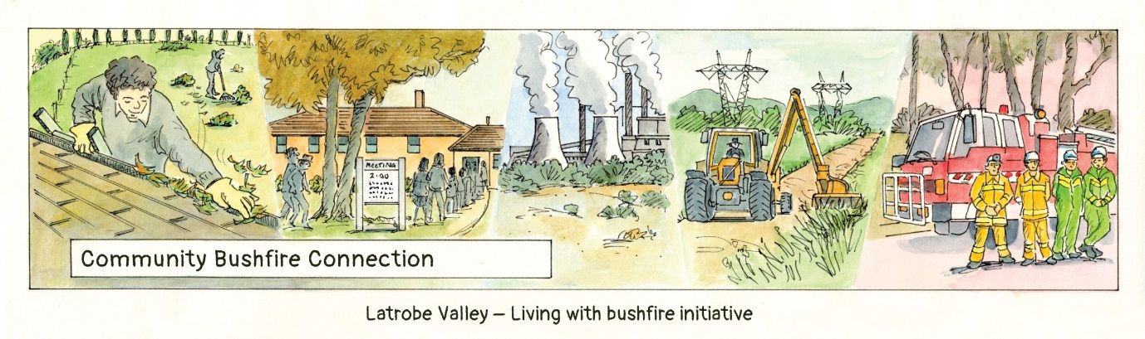
Evaluation Report

Contents
1 Overview 3
1.1. Purpose 3
1.2. Reasons for evaluation 3
2 Audience and end products 4
3 Evaluation criteria and overall assessment 5
4 Evidence 8
4.1. Program management 8
4.2. Webpage 11
4.3. Fire Awareness Evenings 12
4.4. Bushfire Bus Stops 14
4.5. Tomorrow when the fire began 17
4.6. Has the program achieved its desired outcomes? 18
4.7. Where to from here? 22
5 Overall assessment and recommendations 23

Overview

Purpose
The purpose of this report is to evaluate the Community Bushfire Connection program and allow the working group to report to the funding body EMV on meeting its funding requirements. Evaluation covers four aspects :

Delivery – did the committee deliver a program consistent with its funding agreement
- Was it inclusive, everyone owned process and outcome
- Did we do what we said we would do
- Did we effectively market the program

Effect -was the program well received
- What did people think
- Did it influence or inform their thinking
- Did they come (attendance)

Impact – did it contribute to desired outcomes
- Are people more connected
- Has it influenced plans or thinking
- Do more people have plans

Learning
- What could improve next time
- What worked
- What didn’t or could be improved

Reasons for evaluation
The purpose of the evaluation of the Community Bushfire Connection project is to:
- Report on achievements of the project
- Quantify the impacts and outcomes of the project
- Provide lessons learnt for the working group and participating agencies for planning of future events.
- Compile evidence of the impact of the project to assist in determining a wider adaption across the region.
- Compare response to the project between different communities.
- Determine future direction, in particular, whether to hold the Living with Bushfire Conference agin in 2018.
- Audience and end products
Audience | End product | Timeframe
Working Group | Report | March 2018
National Community Grants Fund | Report | March 2018
Partner Agencies- DELWP, CFA, EMV, Latrobe Shire, PV, VotV, Fed Uni | Report | March 2018
LEAP Townships | Summary | March 2018
DELWP CFA Executive Portfolios | Summary with Briefing Note | March 2018
Gippsland Regional Strategic Bushfire Management Planning Committee | Summary with Briefing Note | March 2018
Public | Summary, media | March 2018

Evaluation criteria and overall assessment
Assessment ranking/rubic

Excellent | Good | Acceptable | The Bar | Partial / Improvement | Less than acceptable | Detrimental
Above expectations with unexpected outcomes | Above expectations | Met expectations |  | Partially met expectation but good learnings achieved to justify the program | Below expectations or no evidence to support or justify program | Evidence of a detrimental effect

Project objective or component | Questions | Evidence | Assessment
Did the working group deliver a program consistent with the Funding agreement | Did the working group do what it said it would?  Was the program development and delivery a collaborative and inclusive process  Was the program well targeted and marketed | Working group minutes,Program of events  Working group minutes , working group interviews, Debrief  Communications plan | Above expectations  Good – some scope for improvement  Good – some scope for improvement
 | The working group achieved its objectives in an efficient and effective manner | Minutes  Delivery of outputs to budget and time | Good
Was the program well received | Was it well attended? – level of community participation  What did people think? – participant satisfaction | Attendance numbers as against pre determined targeted thresholds  Survey monkey, interviews with participants | Good – above predetermined levels  Good
 | The working group demonstrated a good understanding of the communities involved | Debrief | Good – Issues with engagement of some , could have nominated working group leads for each community
 | There is enthusiasm for future events | Surveys | Good
Has the project achieved the intended outcomes? (assessment criteria) | Communicating with and educating people about bushfire risk:  How has involvement changed their understanding of risk? | Survey results  Survey results and structured interviews | Good  Good
 | Changes in knowledge and planned behaviours in preparing for bushfires?  Has the project stimulated involvement in township level planning? | Survey results – 91 % participants surveyed have improved risk knowledge and changed fire plan thinking  No evidence to date | Good  Less than acceptable in short term monitor long term
 | Do people feel more connected?  Is there evidence of improved connection between agencies, communities and researchers: | Survey results  Survey results , interviews , participation profile in program delivery | Good  Excellent
 | Has it influenced plans or peoples thinking? Empowering individuals and communities to exercise choice and take responsibility  Evidence of improved community and agency fire planning? | Survey results  Stories from sessions  No evidence to date | Good  Less than acceptable in short term monitor longer term
What did we learn from each event? | What went well?  What could be could have been done differently?  What was most effective?  What was least effective? | Survey results  Debriefs  Interviews | See learnings section
What has changed as a result of the project? | What have we learnt?  How will this improve future community connection events?  Unexpected benefits or outcomes? | Debrief  Interviews | Provided insights to influence future events

Evidence

Program management

The program was initiated in Dec 2016 with a meeting of representatives to discuss the grant and whether to proceed.

Following agreement , a working group was established with Terms of reference and nominated chair and representatives. As a first action a web page was developed to be the main portal for the program development and also a legacy site in its own right.

The working group developed a project plan and program of events as well as the program brand ‘Community Bushfire Connection”. The project plan was signed off by all participating groups in May 2017.

Over the year 15 project team meetings were conducted and minuted,

Evidence of the effective and efficient management of the project include :
- The program web page
- Working group terms of reference
- Working group minutes
- Survey feedback
- Program grant completion report

Survey feedback ….
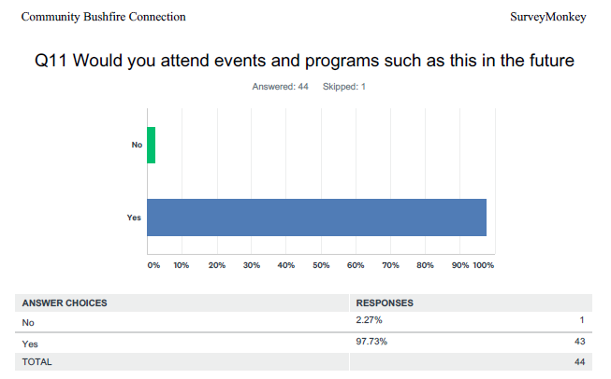

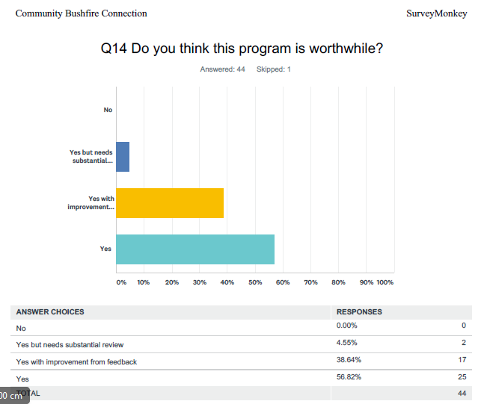

Learnings and issues in program management included

What went well ….
- Project itself was a great example of Safer together relationship building between agencies and community
- A huge amount of effort, impressive commitment from all working group members and organisations
- Grant success : Funding is key as it allows you to do stuff
- Showbags were good but a lot of work
- Early planning and commencement
- Webpage is good, - there is a lot of potential to link between it and facebook,

Suggested improvements
- Need to consider a paid program manager – this is a big drain on full time staff, maybe align to CBBM position in DELWP
- could we rationalize the program , spread it out or at least explain better that the bits are part of a whole
- Get more community partners – neighborhood houses etc
- Add a research page and profile key work on webpage
- Use a short newsletter to keep senior agency staff informed of progress
- Maybe you could have a full day program in a town – eg a school visit, a bus stop, a field trip , an inspection of a property , a bbq and talk
- Do we need breaks between program stages
- Do we need to delegate a manager for each stage / township – governance model
- Run a fire photo competition on the webpage and announce an award at the last event
- Run a school competition like Fire Awareness Awards
- Do you expand out or keep focused on the valley
- Change it up – do a LWB style event next year
- Try to run various aspects in conjunction with existing events in towns eg the Tyers Arts Festival

Recommendations

- Continue with the program next year with a new format and approach
- Rationalize the program next year to reduce the workload
- Seek funding mechanism to allow for a dedicated project officer and funding of events
- Seek to involve more community representatives next year
- Ensure better connection with Brigades in townships to integrate program with their schedules and allow them more ownership
- If continuing small town events initiate an EOI process so townships nominate to be a part of the program
- Review target audience for next year – focusing on informed community leaders
- Review governance arrangements

Assessment | Above expectations

Webpage

Evidence of the success of the webpage include :
- The webpage content
- Number of site visits

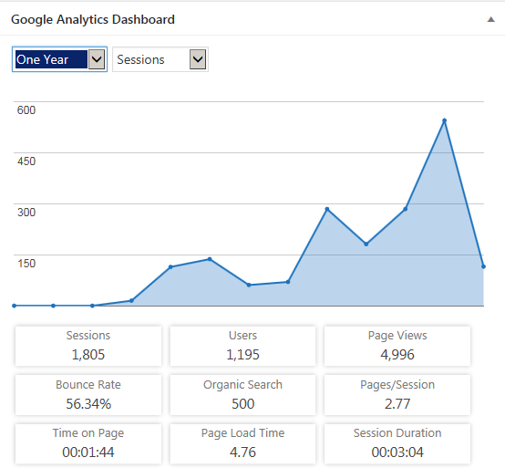

Note 5,000 web page visits by 1200 users

Comments on the Web page from survey

Its very user friendly - it might be nice to have an "after bushfire season event" to celebrate all the work done, community participation in these events and if all goes well and there is no fire, combine this with a general community happiness event that the fire season is over

easy to get around liked the personal touch with pictures and profiles of organisers , makes it more human

love it be good if it had info on the bushfire royal commissions findings and also the Hazelwood one

Learnings and issues in webpage management included

- Need information regarding the Royal commissions and outcomes
- Need more stories from community and maybe ‘plan stories’
- Could have a competition element – eg picture competition
- Need an ongoing custodian and to use the page to drive next years events
- Improve use of facebook page to take people to the site

Recommendations

- Maintain the webpage as a project legacy
- Review content and look to integrate royal commission information, research and more community stories
- Stronger use of social media to promote and bring people to the web page content

Assessment | Above expectations

Fire Awareness Evenings
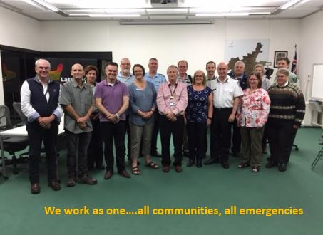
Evidence of the success of the fire awareness evenings include :
- Attendance (Benchmark per session - 20, achieved average was 45)
- Survey feedback
- Event management

Expectations | How well has the expectation been met?
 | Not at all | Partially | Met | Exceeded
Communications about the event reached the target audience?
Participation met expectations in Tyers. (27)
Participation met expectations in Yinnar.(45)
Participation met expectations in Moe.(65)
Participation met expectations in Morwell.(35)
Those that effect change were prominent and involved.
Each event was delivered as outlined in the project plan.
The Working Group achieved the objectives in an efficient and effective way.

Comments received in the survey included :

Excellent presentations (Moe), excellent simulation table, really brought home how the speed of the fire, how it moves in different terrain and how it spots ahead.

I think most people know what was discussed on the night. It went a little too long.

Informative, well run, appreciated by locals.

I liked the mix of speakers from experts to locals

Learnings and issues in fire awareness evenings included

What went well ….
- 3 tiered talks ( expert, agency, local) worked but time management an issue
- Sim table a hit and could have used as an arrival conversation starter
- Concept of small town visits and series of events worked ok but need to work more closely with townships maybe an EOI process – sense people can opt in rathr than here it is going to happen to them
- John Crane and Kev Tolhurst presentations excellent

What could improve
- A history of fire in the valley talk may have been good
- A presentation showing the webpage bit may have been good
- Townships need a say in speakers – eg fire ecol at Yinnar
- Given bus stops visited towns wonder if it would have been better to have a one day conf style event
- Instead of a half hearted catering thing (eg light refreshments will be provided), could have just advertised and arranged as a meal provided thing eg start 6pm – tea provided break (mingling opp) – continue on
- What about a field day – bus trip
- What about a mix – an evening seminar and a field trip option
- Run an “I am prepared” comp – eg a mini valley Fire Awareness award
- Build in more on fire plan awarenss
- Have a smaller township scenario exercise in the locations
- Times and locations – FRiday night in Morwell???
- Videoing the talks and sticking on line would have reached more people and been a legacy
- Time management an issue at some nights

Recommendations

- Run an EOI process with communities to host a fire awareness evening
- Utilise the simulation table in interactive part of evenings
- Ensure good time management
- Review agenda / structure

Assessment | Exceeded expectations in attendance  Some issues with management/time/format

  - Bushfire Bus Stops
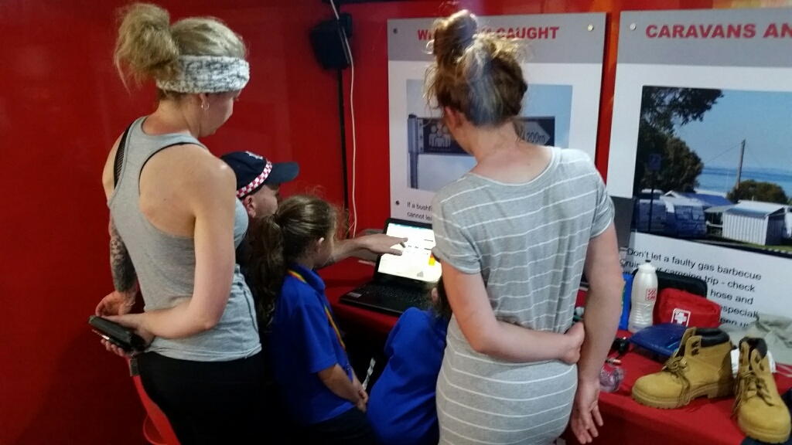
Evidence of the success of the bushfire bus stops include :
- Attendance (Benchmark per session - 10, achieved average was 25)
- Survey feedback
- Event management

Expectations | How well has the expectation been met?
 | Not at all | Partially | Met | Exceeded
Communications about the event reached the target audience?
Participation met expectations in Tyers. (12, 30)
Participation met expectations in Yinnar.(25)
Patricipation met expectation in Toongabbie (35,15)
Participation met expectations in Moe.(25, 20)
Participation met expectations in Churchill.(25)
Participation met expectations in Yallouorn N (20)
Patricipation met expectations in Boolarra (45, 20)
Participation met expectations in Callignee (55)
The Working Group achieved the objectives in an efficient and effective way.

Comments received in the survey included :

Very informative, and the crew on the bus made every effot to understand our specific situation.
Show bags were good
Knowledgeable staff, good technology, able to visualize my place and understand risks

Learnings and issues from bushfire bus stops included

What went well …………….
- Weekends stops worked better than I expected
- Variable messaging boards a day ahead worked well
- Staff were really good , friendly, approachable and knowledgeable
- Bus super impressive
- Organisation and schedule – kept to well , good pre planning
- Multi agency feel to stops
What could improve …
- Could have coordinated with school stops, eg done a school ed bit for an hour then gone to plan and community model
- Rationalise presenters – sometimes too many – intimidating to visitors
- Look at combined events – eg a bus stop preceding a fire awareness night
- Missed a chance to coordinate with CFA open days
- Perhaps could have had an EOI for who wants one (towns) to get more ownership over
- Coordinate with brigades (align with CFA open days) – more direct involvement and local township groups
- Review stops and times

Recommendations

- Coordinate stop schedule with CFa and schools to integrate into township schedules and allow an education component
- Have large mockups of model plans
- Provide large scenario phoenix runs per town

Assessment | Exceeded expectations in attendance  Some issues with integration with local brigades

  - Tomorrow when the fire began

Evidence of the success of the bushfire bus stops include :
- Attendance (Benchmark per session - 50, achieved average was 75)
- Survey feedback
- Event management

Expectations | How well has the expectation been met?
 | Not at all | Partially | Met | Exceeded
Communications about the event reached the target audience?
Participation met expectations in Wednesday (75)
Participation met expectations Schools .(100)
Participation met expectations in Thursday .(45)

Comments received in the survey included :

Good idea, more time for audience participation and questions, too much emphasis on the agencies
Very engaging and good table talk
Highlighted some flaws in my plan

Learnings and issues from Tomorrow when the fire began included

What went well……….
- Pollev ( but more oversight with students)
- Sim table a treat
- Independent facilitators and 2 worked really well
- 2 sessions a challenge to get numbers to both but worked ok – different vibe and learnt from first
- School session a highlight but more prep with kids – and earlier engagement to ensure alignment with curriculum not just an end of year add on
- Excellent exercise and feedback, even though a long session still energy at end of the night
- Establish that Gippsland is fire prone by showing overlaying maps of fire history
- The use of phoenix, Owens work and simulation was excellent

What could improve
- A pre event run through or a chance to brief table speakers – so they don’t ramble
- Late Nov is risky , due to fires we nearly lost a lot of speakers and clashed with CFa events
- Wonder if you could do on-line? Good to try for one session – eg as a webinar
- Should have had a DELWP uniform up front in one of the roles
- Run back to back with fire awareness night
- Shorter simulation, time for debrief at end of session and discussion during
- Maybe a faster pace, less informing about roles more snappy decision making. 3:30 and 4:30 sessions a bit repetitive, could have built in issues more into second one if you kept it and not had both of them esp as both situational reporting so much – reckon it would have been better to keep one and emphasise the 6pm discussion more
- Maybe start earlier and build in tea – and promote as a catered event
- Need an independent script reviewer, little feedback from busy working group and needed an outside eye
- Build in a family experience to check in with during the scenario , as alternative to agencies
- Smaller sessions at township level may work better – eg the Orbost model, or be an add on
- Ramp up the realism – smoke, noise etc
- Videos great could have had pictures of forest fire fighting a bit more, eg rakehoe lines etc
- Need to learn from other scripts/scenarios

Recommendations

- Redesign to be more hearing from property owners and community
- Ensure more table discussion time
- Ensure good time management
- Independent review of script,
- Consider smaller township events
- Utilise better more sophisticated AV to get sounds etc

Assessment | Exceeded expectations in attendance  Some issues with integration with local brigades

  - Has the program achieved its desired outcomes?

Communicating with and educating people about bushfire risk:- has the program changed peoples understanding of risk

Survey result
Of 41 responses 36 indicated they felt their knowledge of bushfire risk had improved. Examples of feedback are :

Yes we certainly do. Although we were aware when moving to the bush that we would live in a bushfire prone area we accepted the risk. We also knew we needed a better understanding of fire, its management to be proactive and prepared. That is why to us the events were so valuable. We are from North Queensland and experienced Yasi, Larry and Steve so we are well aware not to be complacent

Moe South resident - I knew it was risky but to have it explained eg where fire could come from was really good

Influencing plans and peoples thinking

When asked if the program had helped people rethink or change their plans the following responses were received, showing a high application of or influence of information on peoples plans which was a core aim of the program.

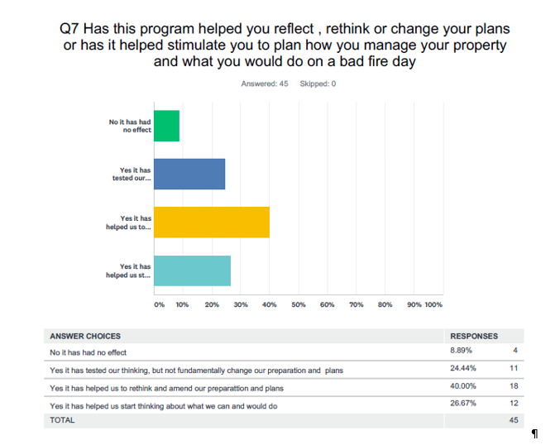

Assessment | Met expectations

Do people feel more connected? Is there evidence of improved connection between agencies, communities and researchers

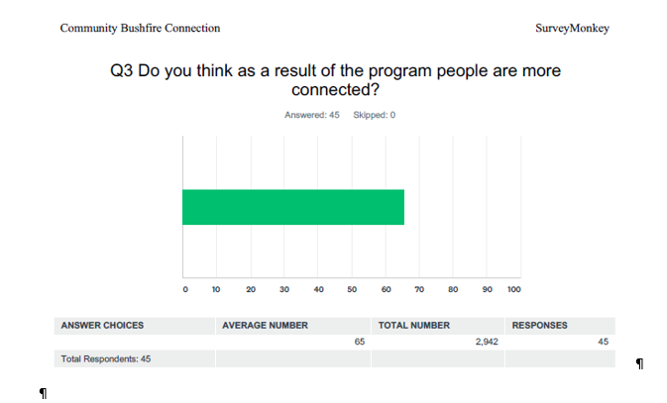
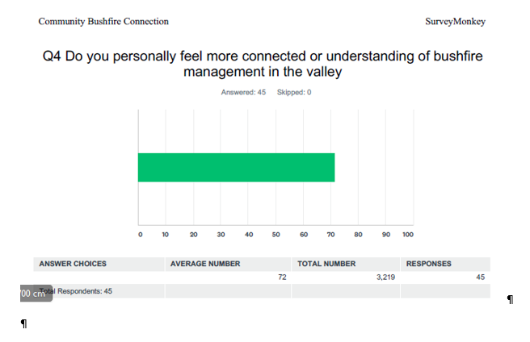
These results suggest a high level of connection across participants and organisers and a strong foundation for future events

Assessment | Met expectations  Involve broader community groups in future program

Has it influenced plans or peoples thinking? Empowering individuals and communities to exercise choice and take responsibility. Is there evidence of improved community and agency fire planning
There is no evidence of improved community and agency fire planning however the following survey result suggests the program has influenced individuals thinking and planning , even experienced people noted that the exercise had changed their thinking.

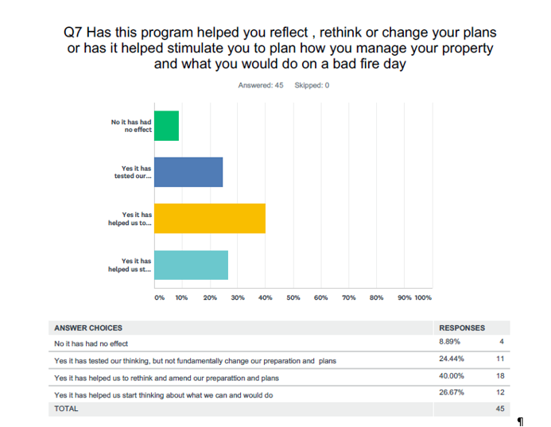

Assessment | Met expectations

  - Where to from here?

Overall impressions of organising committee
- Was it worthwhile , yes it was a good program and a good experience
- Would we do it again – no , huge effort, especially not in November
- If repeat it would be in a different format
- Do a smaller program in a bigger footprint?
- Target audience – went for uninformed but should we target the engaged
- Community leadership course – the engaged/informed – at Fed Uni with Steb
- The future captains – kid bit like Broadening horizons
- Mini conf where graduates recongised
- Bus stops – link to CFA open days
- Video sign relevant to towns
- Linik bus stops to school visist
- Which brand going forward LWB or CBC
- Build in more experiental material and AV like sounds of helicopter overhead, 3 D visuals etc

From the survey (Question 9) the following were identified as areas people would have like more information on

- Landscaping around you house in fire risk areas
- Management of pets and livestock
- Evacuation and care of the vulnerable
- Traffic management
- More time to discuss plans and pick ideas from others – eg model plans
- House design and retro fitting options

Some overall themes to consider moving forward are
- Can the program provide a different approach for larger settlements and smaller communities rather than a “one size fits all “ approach
- Need to balance focus on high risk communities and townships with those ready and willing to participate

Overall assessment and recommendations
The program met its objectives and was a success

The working group need to consider and decide if proceed with the program however a number of recommendations if proceed are
- The program was too ambitious and too much work , need to rationalize the program
- The bus stop events should be part of any new program but integrated better with local CFA brigade events and school visits
- The focus should switch to empowering the engaged and active, not the ‘uninformed’
- The webpage should be sustained as a program legacy
- A dedicated program manager is needed if it proceeds
- A leadership, capacity building, community planning course be offered to empower community leaders
- A shorter conference (one day) be arranged including graduation of the leadership group
- The Tomorrow when the fire began session be reviewed either as township specific sessions or as an abridged add on to the conference

